Lab Task 05
Zain jabbar (323)
AI (lab)
Q:1
Trace the supplied tree by hand using Minimax.
What I did
1. This code implements the **Minimax algorithm** on a game tree, starting with the root as a **MAX** node.
2. MAX nodes choose the largest value; MIN nodes choose the smallest value.
3. When the function reaches an integer, it treats it as a terminal value and returns it.
4. `-math.inf` and `math.inf` are starting values that let MAX and MIN update their best scores correctly.
5. The tree’s left branch returns **5**, its right branch returns **0**, so the root’s Minimax value is **5**.
6. No error message or earlier code is shown, so I can’t say what specific error you found or fixed; the code shown appears valid.
Code screenshot
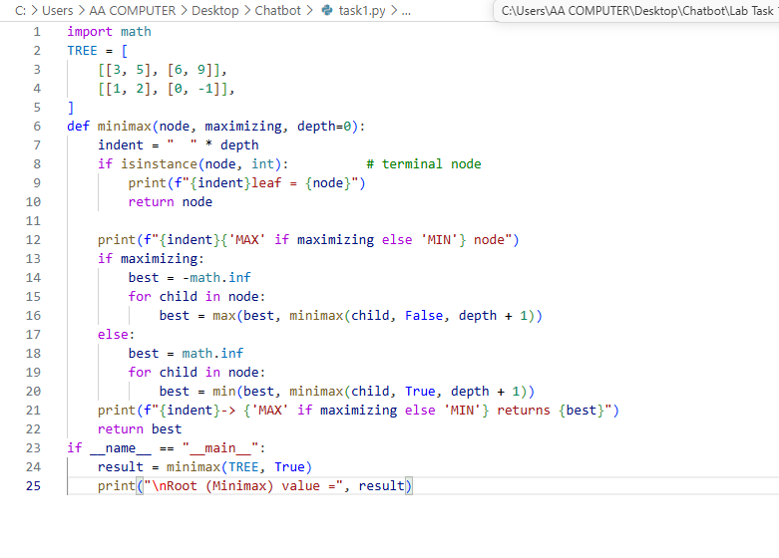
Code Explanation
This code uses the **Minimax algorithm** to calculate the best outcome in a game tree, assuming both players make optimal choices.

- `TREE` represents the game tree. Its numbers (`3`, `5`, `6`, `9`, `1`, `2`, `0`, `-1`) are the final scores at the leaf nodes.
- `minimax(node, maximizing, depth=0)` examines the tree recursively. `maximizing=True` means it is MAX’s turn; `False` means it is MIN’s turn.
- If `node` is an integer, it is a leaf, so the function prints and returns that score.
- At a MAX node, the function chooses the largest child value. At a MIN node, it chooses the smallest. `depth` controls indentation in the printed output.
- Starting from the root as MAX, the left side evaluates to `max(3, 5) = 5`, then `min(5, 9) = 5`. The right side evaluates to `max(1, 2) = 2`, then `min(0, -1) = -1`.
- Finally, the root chooses `max(5, -1) = 5`, so the printed Minimax value is **5**. No specific error is shown in the code.
Code Run Screenshot
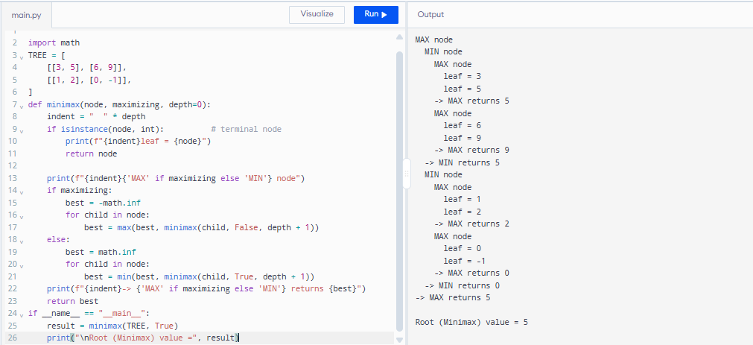
Q:2
Add a leaf-evaluation counter to both algorithms.
What I did
1. This code compares **Minimax** and **Alpha-Beta pruning** on the same game tree.
2. Minimax checks every leaf, while Alpha-Beta skips branches that cannot change the final decision.
3. The `counter["leaves"]` value tracks how many leaf scores each algorithm evaluates.
4. Both algorithms return the same root value: **5**; Minimax evaluates **8** leaves, while Alpha-Beta evaluates **5**.
5. The `assert` checks that both root values match and prints a confirmation if they do.
6. No specific error message or earlier code is shown, so I can’t identify an error you fixed; this code appears to run as intended.
Code screenshot
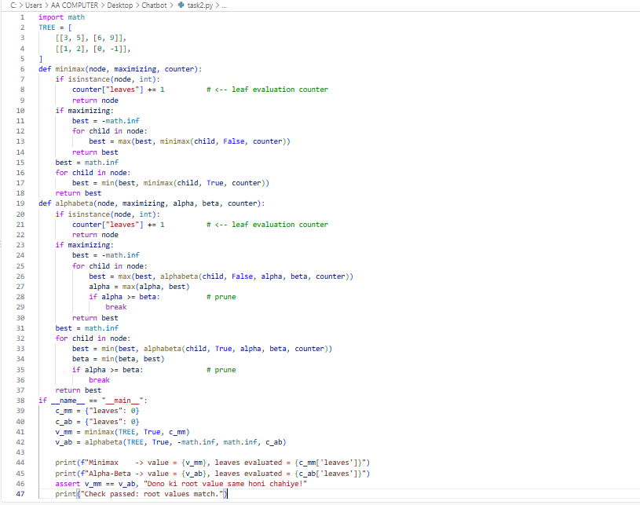
Code Explanation
This code compares the **Minimax** algorithm with **Alpha-Beta pruning** on the same game tree.

- `TREE` contains the game tree’s leaf scores. MAX tries to choose the highest score, while MIN tries to choose the lowest.
- `minimax()` explores every branch and increments `counter["leaves"]` each time it evaluates a leaf.
- `alphabeta()` also finds the best score, but uses `alpha` and `beta` to stop exploring branches that cannot change the outcome.
- Both algorithms return a root value of **5**. Minimax evaluates **8 leaves**; Alpha-Beta evaluates **6**, because it prunes the final `[0, -1]` branch.
- The `assert` verifies that both algorithms return the same value, then prints “Check passed” if they do.

Code Run Screenshot
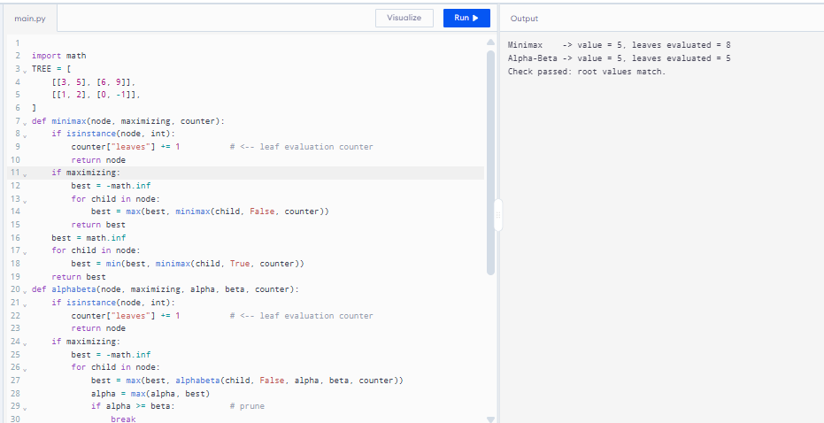
Question 3
Reorder branches and observe how pruning changes while the Minimax value remains the same.
What I did
This code tests how **child ordering affects Alpha-Beta pruning** while keeping the Minimax result unchanged.

- `minimax()` calculates the game-tree value and counts evaluated leaves; `alphabeta()` calculates the same value but prunes branches that cannot affect the decision.
- `reorder()` creates versions of the tree with the original, reversed, best-first, or worst-first child order. It uses Minimax values to decide what “best” and “worst” mean.
- The loop runs both algorithms on each tree, checks their answers with `assert`, and prints the result and number of leaves evaluated.
- The root value stays **5** for every ordering. Minimax evaluates **8 leaves** each time, while Alpha-Beta’s leaf count depends on ordering: **6** for original and best-first, and **8** for reversed and worst-first.
- No specific error message is shown, so I can’t identify an error you previously fixed. One measurement caveat: the leaf counts do not include the extra Minimax work done inside `reorder()` by `value_of(
)`.
Code Screenshot
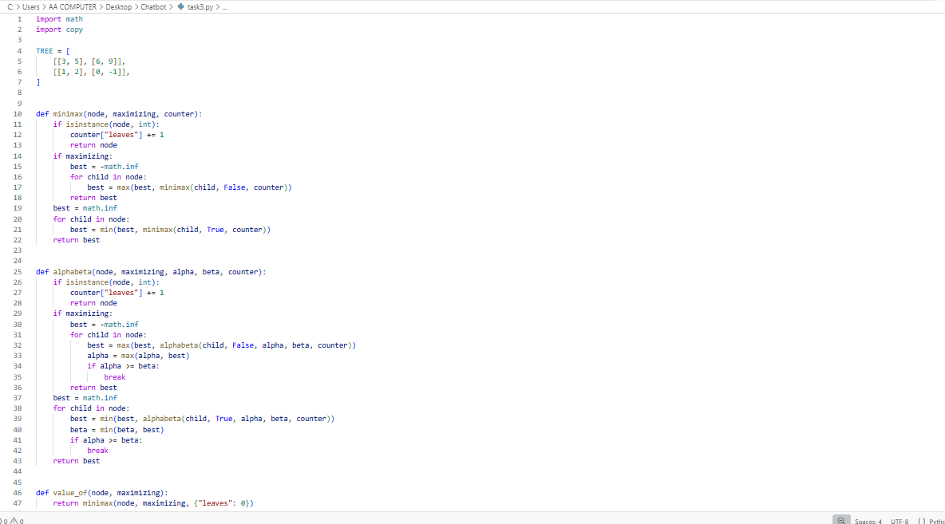
Code Explanation
This code compares **Minimax** and **Alpha-Beta pruning** with different child orders to show how ordering affects search efficiency.

- `minimax()` evaluates every leaf and returns the game-tree value. `alphabeta()` returns the same value, but skips branches that cannot change the result.
- `value_of()` gets a subtree’s Minimax value. `reorder()` recursively changes the order of children: it can keep the original order, reverse it, or put the best- or worst-valued children first.
- The main loop makes a reordered copy of `TREE`, runs both algorithms, checks that their answers match with `assert`, and prints their values and leaf counts.
- The root value remains **5** for all orderings. Minimax evaluates all **8 leaves** each time; Alpha-Beta evaluates **6 leaves** for the original and best-first orders, and **8** for reversed and worst-first orders.
- The final observation means child order can change how much Alpha-Beta prunes, but it does not change the correct Minimax value. No specific error message or earlier version is included, so I can’t identify an error you fixed.
Code Running Screeshot
